**Dialogflow Modules**

1. **Lab locations Intent** –

Currently shows all the semantic labs that are present in the DB.

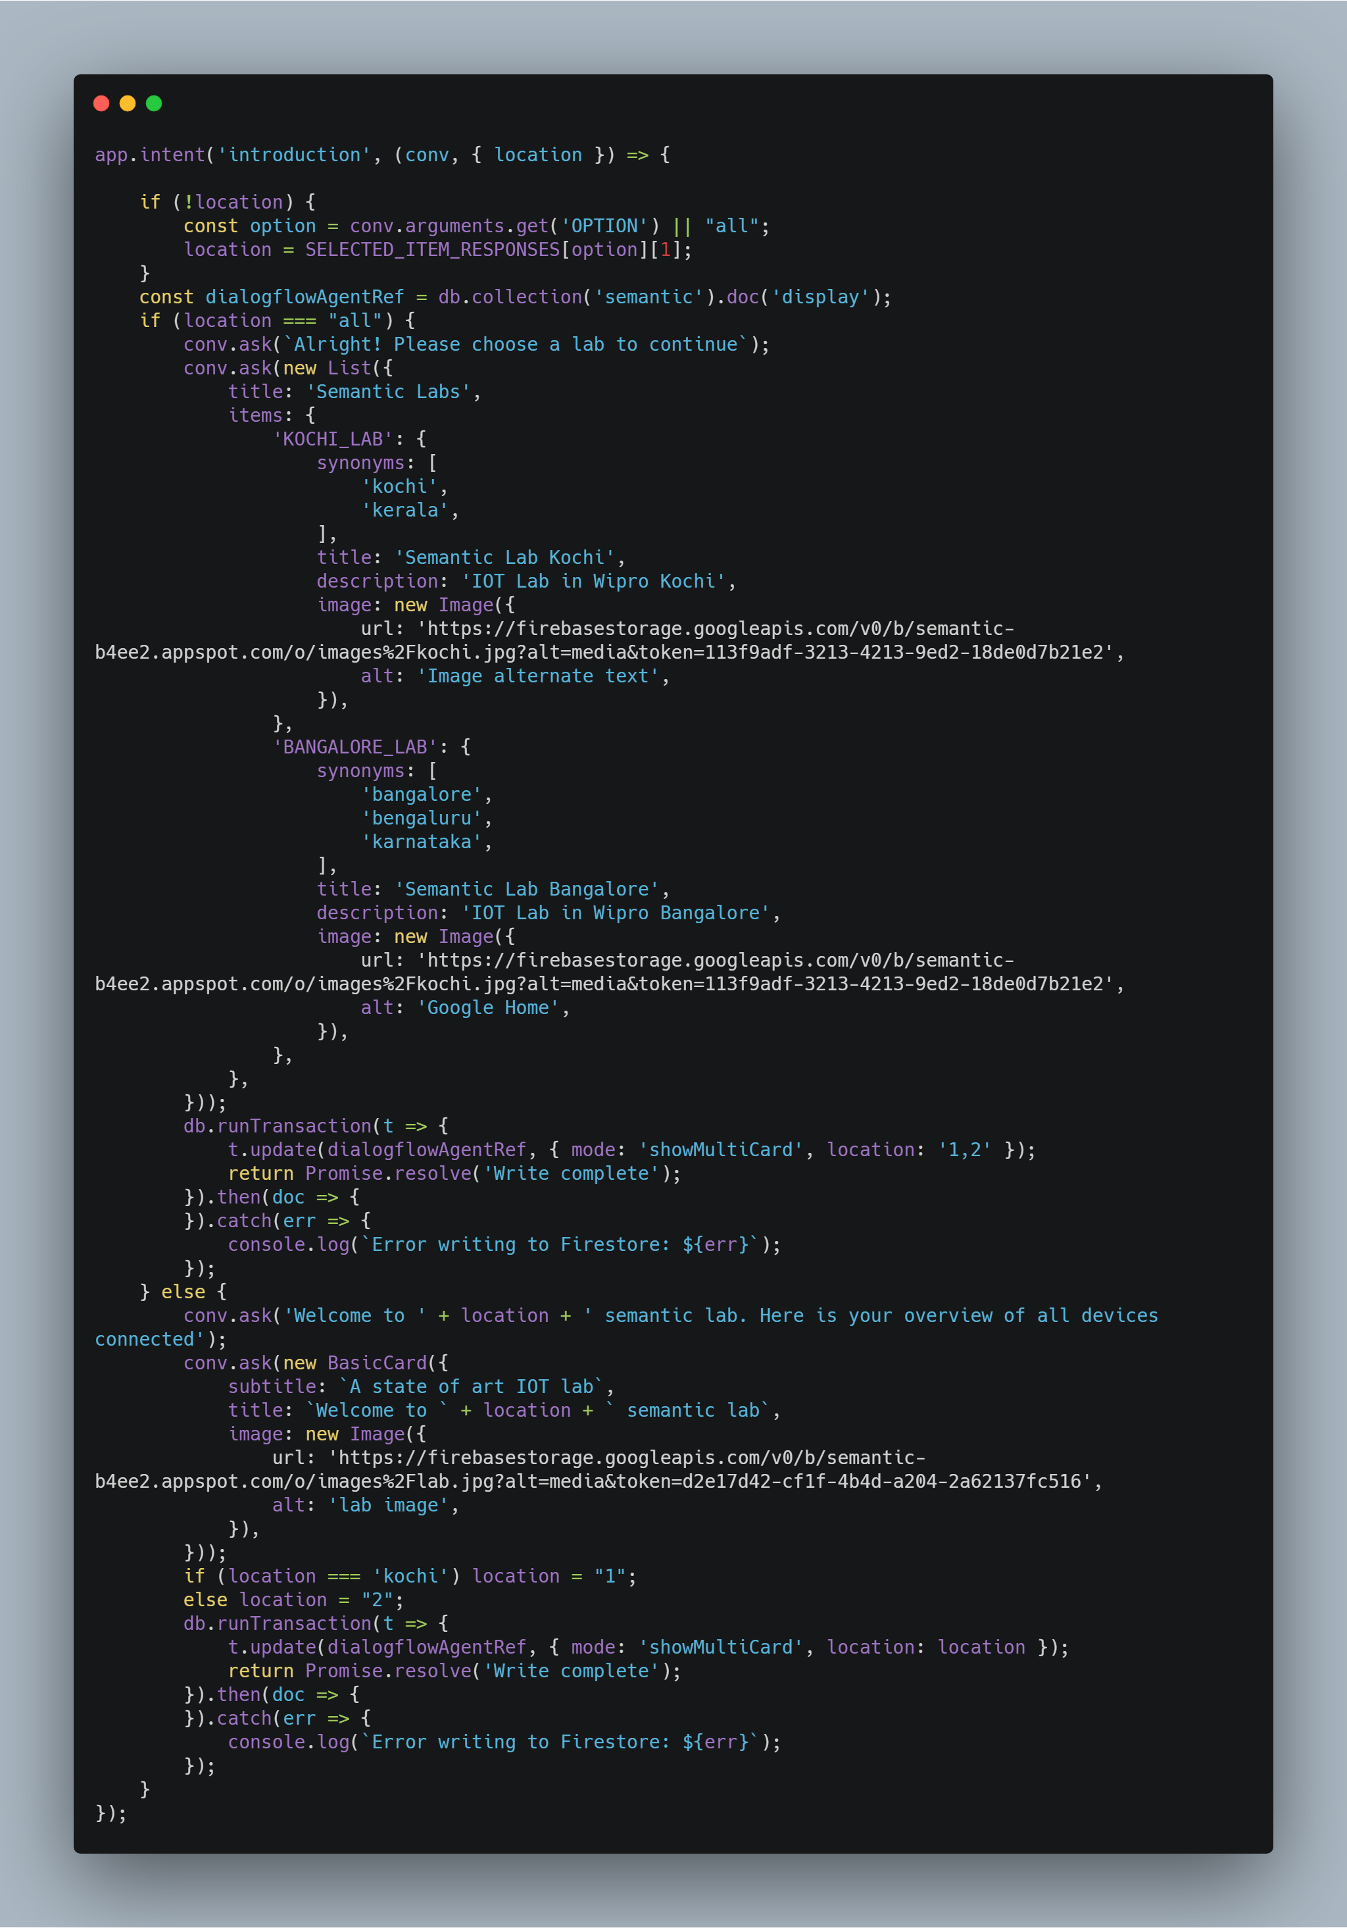

1. **Graph Intent -**

Triggers the graph module in the website and shows rich response based on the sensor invoked through the user query.

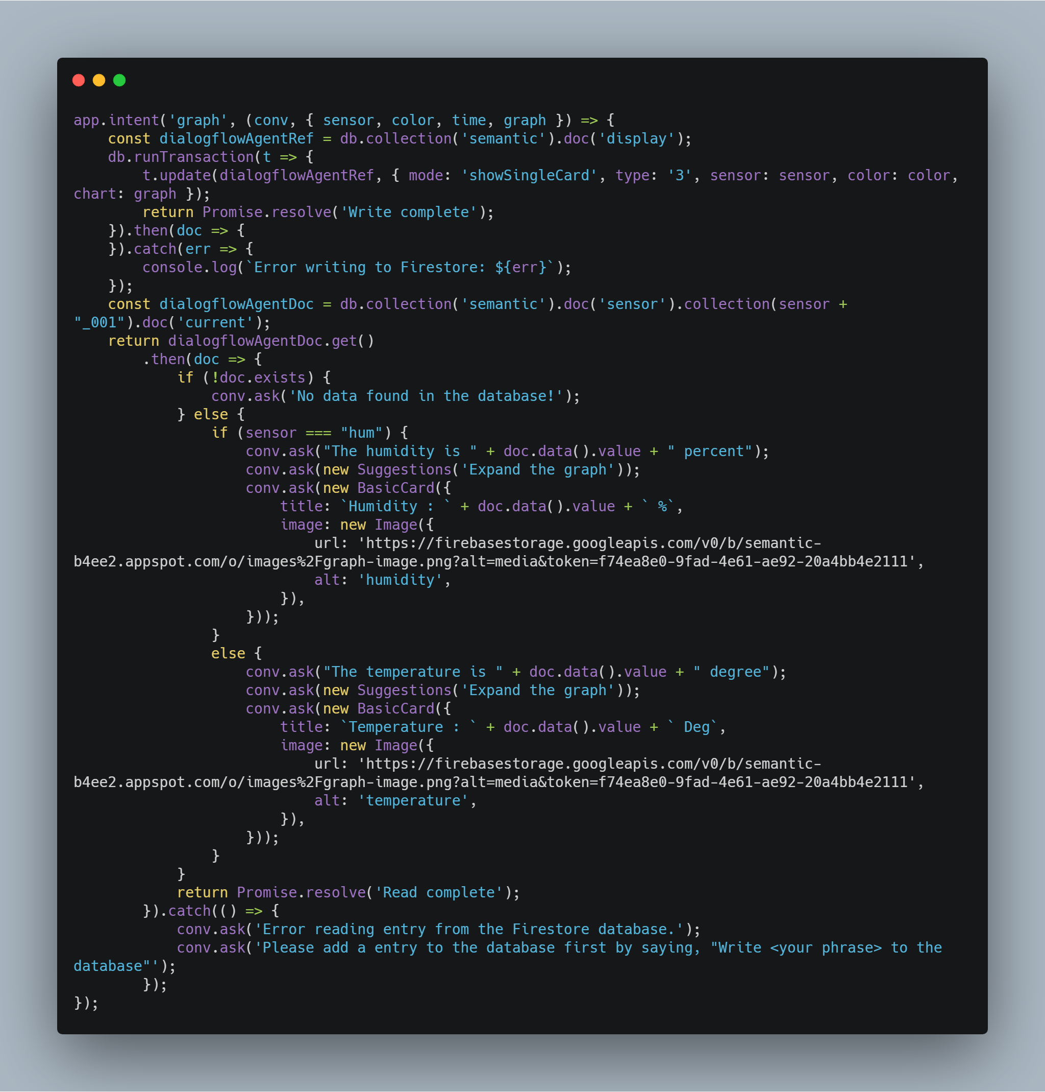

1. **Graph Customise Intent** –

Triggers the graph module with additional properties for graph customisation. Similar techniques can be used to modify other properties.

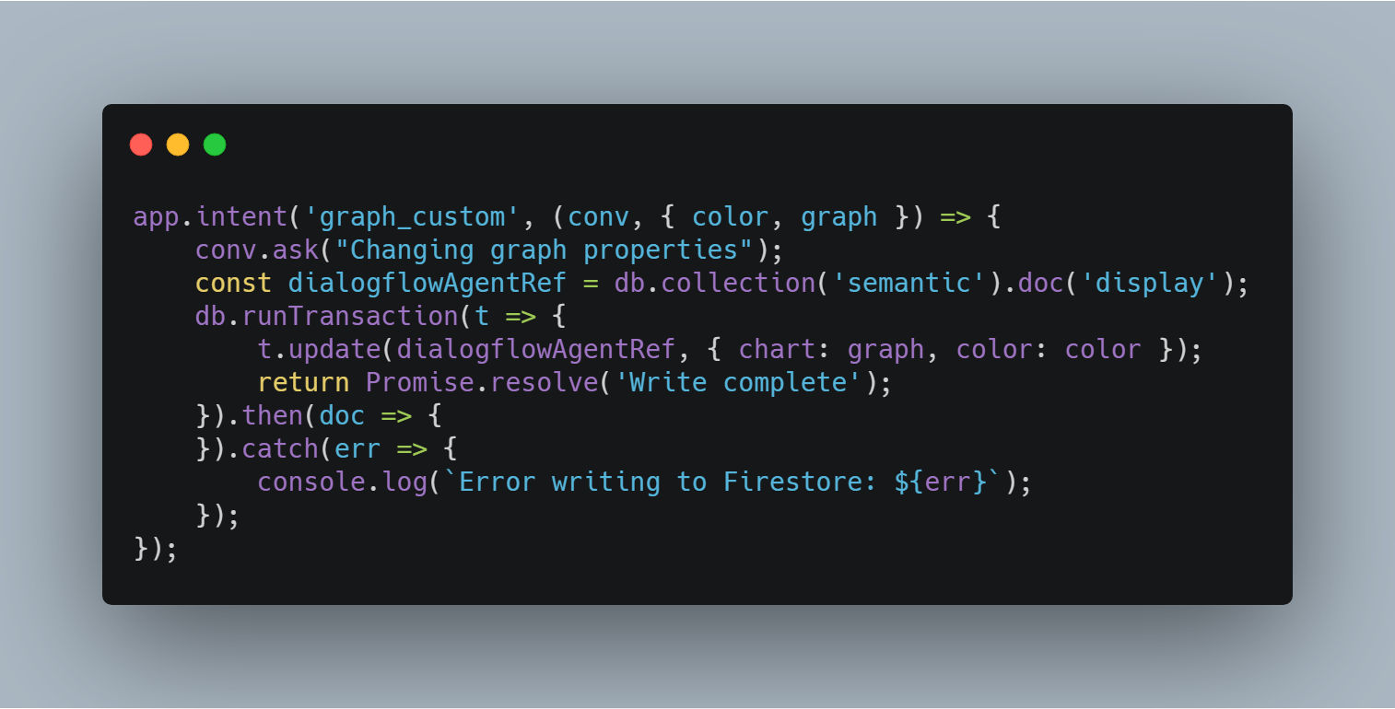

1. **Servo Intent** –

Triggers the servo module in the website and shows rich response to user query. Module currently passes direction extracted from query, additional parameters can be passed if required.

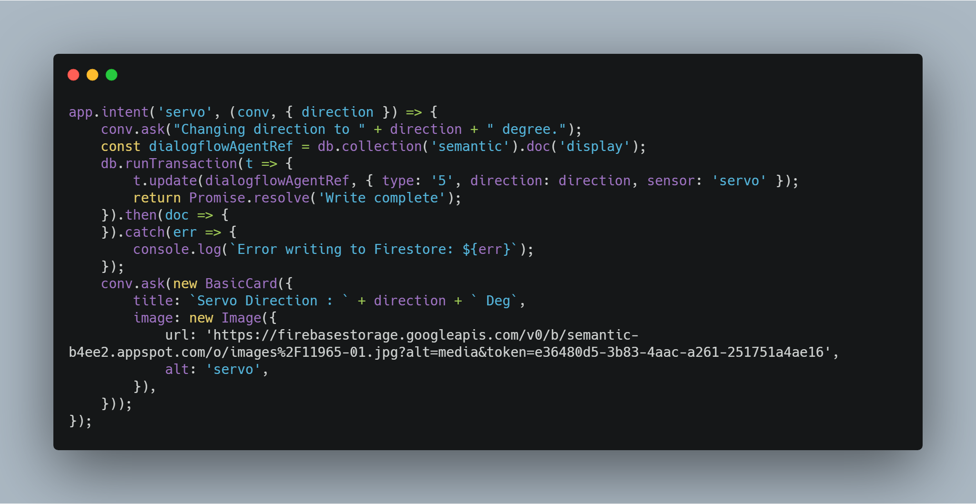

1. **CLI Interface** –

Triggers the CLI module in the website. Currently module supports showing list of files, running python and bash files and file upload to edge device using user voice query. Since Command Line interface was created with full terminal functionality, any terminal command can be made to run via voice interaction with minimal efforts in fullfilment.

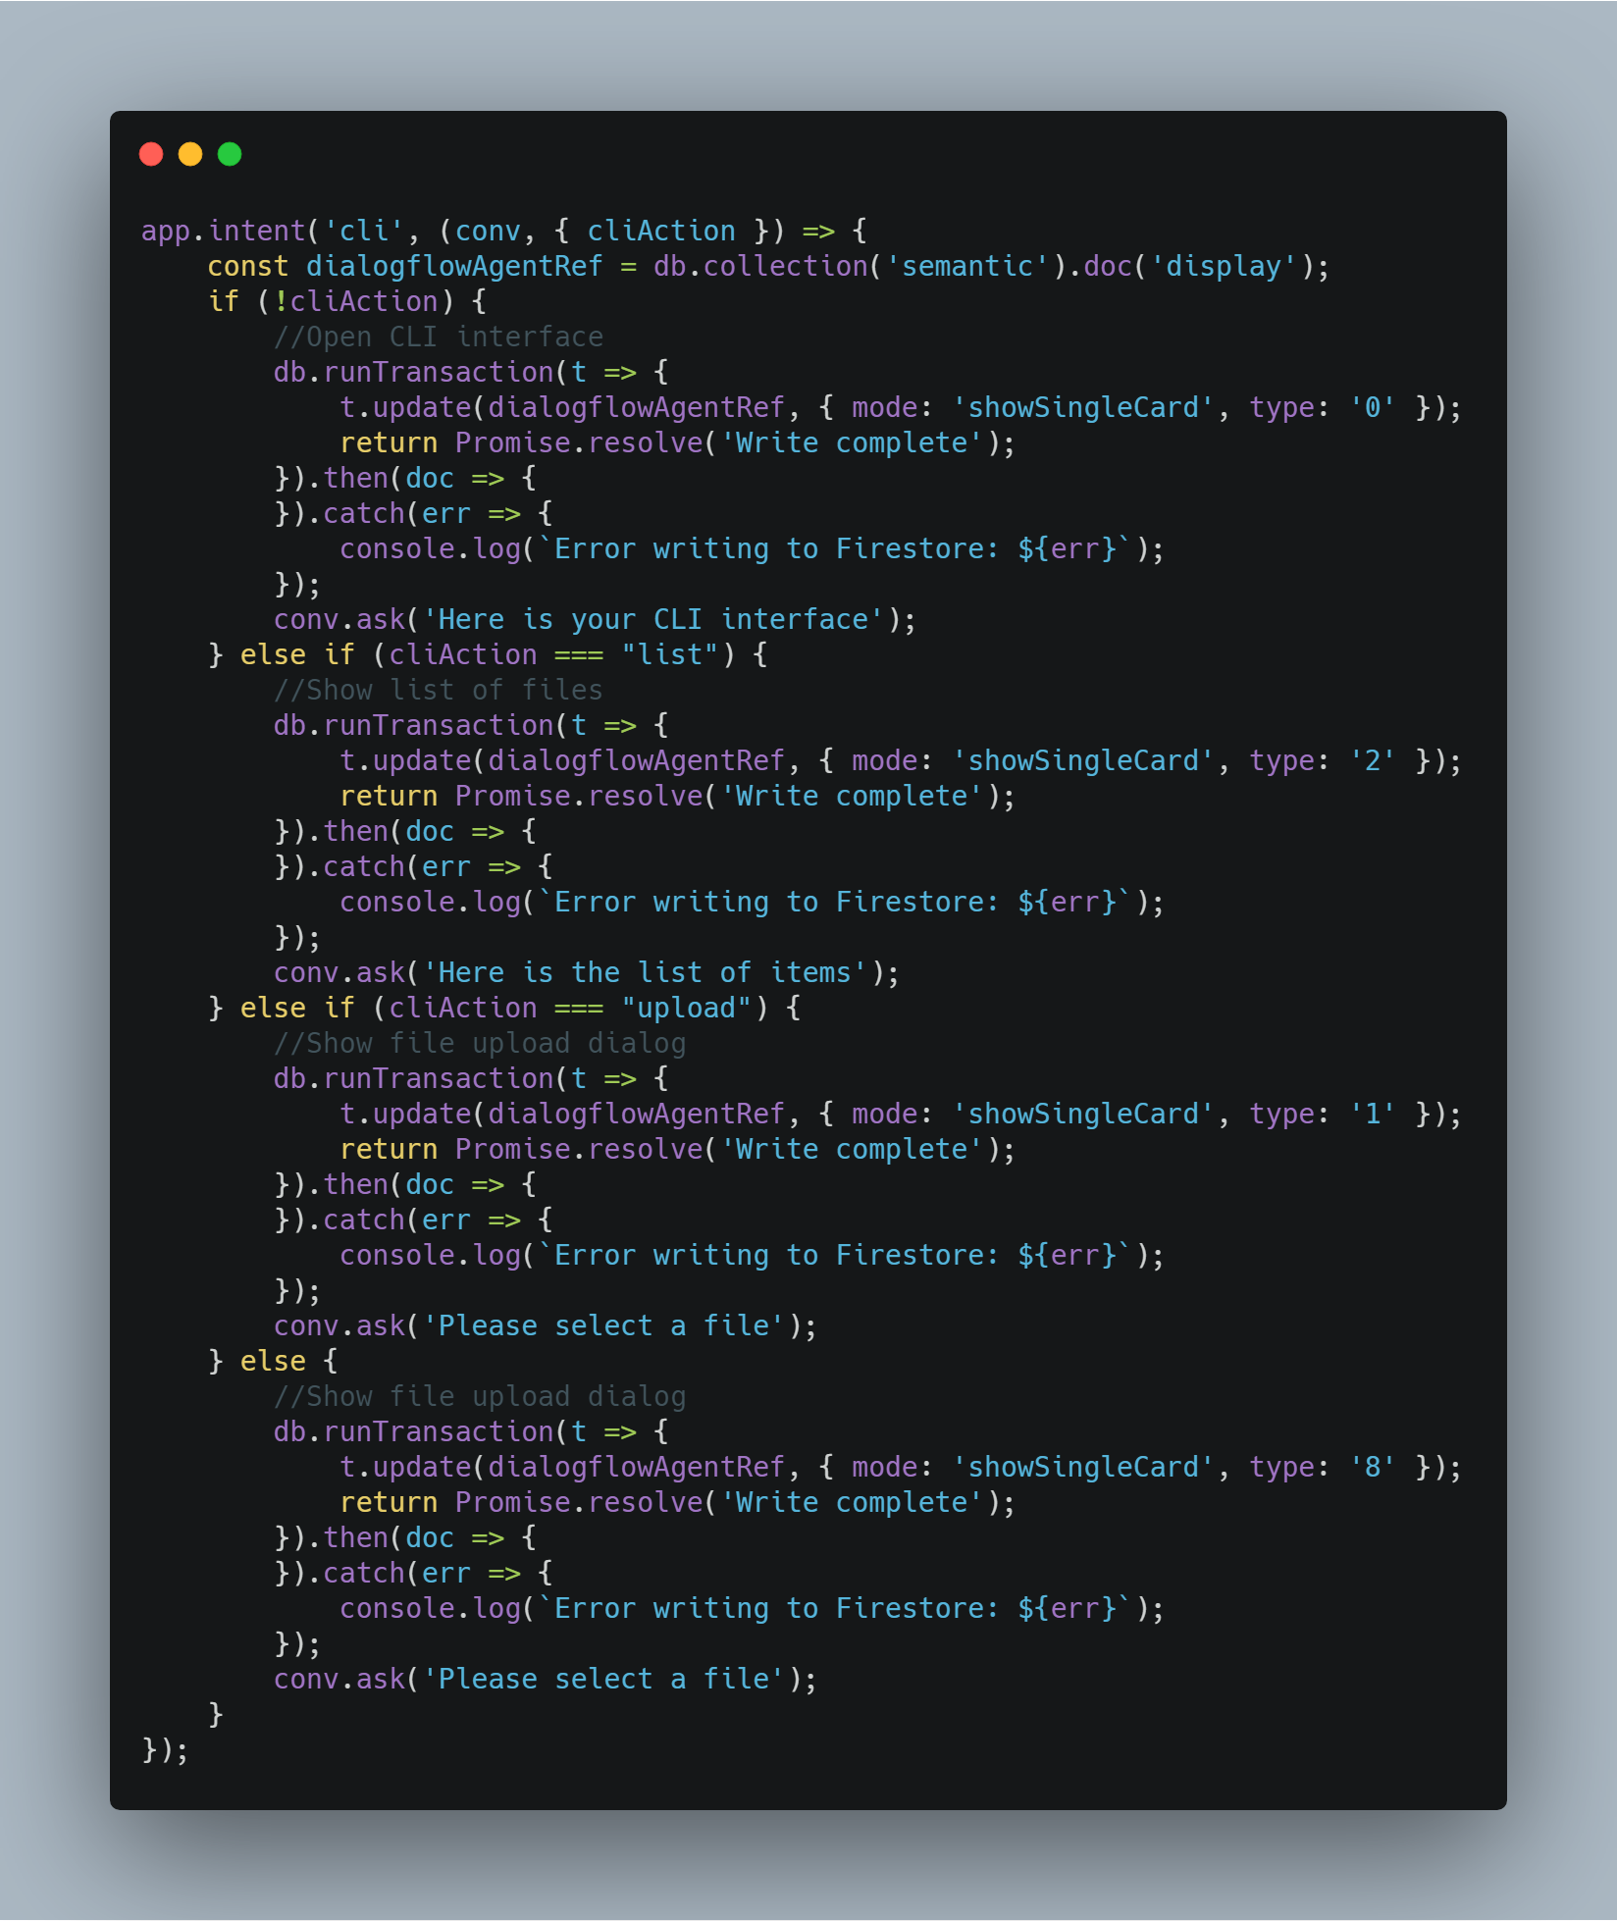

1. **Youtube Module** –

Triggers the youtube module in website, send required url through fullfilment and the website will provide controls formatting for inline video. Youtube data API can be used for finding url based on user query after required entities are extracted and passed as search keywords in youtube api.

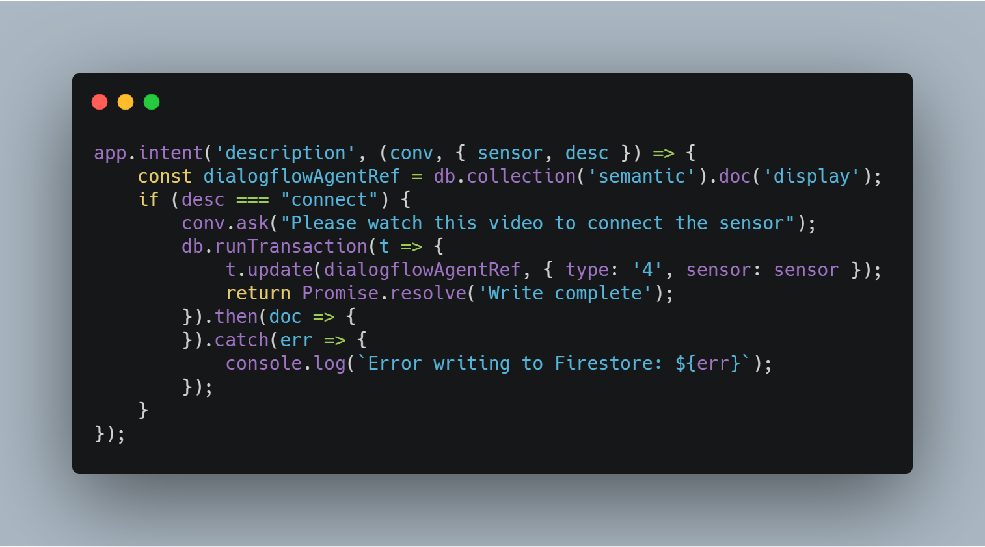

**Initialise the firestore**

